Structural Modeling and Behavior Modeling

Affiliation
Professor
Student
Date

Structural Modeling and Behavior Modeling
Introduction
Successful businesses require an elegant business model with the right delivery channels, marketing techniques, and target customers to ensure profitability. Many organizations argue that an efficient business model is far more crucial than developing the products (Bidmon & Knab, 2018). Therefore, business managers ought to validate their business models' value and confirm that the implemented solutions solve their problems effectively. ABS Management aims to provide an accurate valuation to clients' property based on the available information on market factors, replacement cost, and financial performance. As a result, well developed functional, behavioral, and structural models are essential in improving the organization's services.
Class Responsibility Collaborator cards
A Class Responsibility Collaborator card is a business tool used to design object-based software. The CRC model is divided into three sections. The class involves similar objects, responsibility is the duty performed by a class, and a collaborator consists of a combination of two classes to fulfill obligations. CRC cards can be used successfully in ABS management as a full-fledged modeling technique.
Class Diagram
A class diagram is a structure that describes the system's design by showing the operations, attributes, and relationships among different objects. ABS management can use a class diagram to help developers and other team members to create systems from the business perspectives.

Figure 1. Class Responsibility Collaborator
Customer | Order
Name | Placement date
Address | Delivery date
Phone Number | Order number
 | Applicable taxes
 | Total

Customer
Address
Phone number
Order
Date
Status
Figure 2. Class Diagram
Product
Name
Price
Quantity
Client
Name
Item
Quantity
Price
Company
Name

Use cases
Use cases describe how an organization is used by its customers, partners, and external agencies. Use issues mainly present tasks that directly concern the business partners or customers. Core use cases are external use cases that provide value chain organization; management use cases coordinate the value chain within the organization while support use cases support the value within the organization. The management use case present in many organizations describes the relationship between employees and the CEO in a business.
Business use cases usually function parallel to each other. Use cases can follow an unlimited number of paths representing the business's choices in the description of the workflow. However, use cases are determined by specific events or facts that reflect the organization's goals. One of the assumptions made in a functional business model is that use case instances can occur actively without conflicting. During this development period, company directors should focus on understanding how things should work and solve potential conflicts (Bidmon & Knab, 2018). Alternatively, these problems can be solved by increasing the number of employees during the implementation of new business strategies.

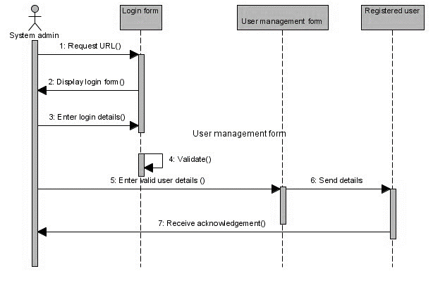

Figure 3. Sequence Diagram

A sequence diagram describes how operations are carried out in an organization. It provides the details of the interaction between objects in a situation of collaboration (Geissdoerfer et al., 2018). Sequence diagrams focus on time by using the vertical axis to show when messages are sent. ABS management can use sequence diagrams to capture high-level interaction between the information system and the active objects. Additionally, sequence diagrams can determine the interaction between objects in a system and the use case.

User Interface

Supply chain

ABS Review

Reservation
Confirmation

Figure 4. Communication diagram

The communication diagram shows the parts or objects of a system and how they interact with sequences. Communication diagrams and sequence diagrams have various similarities, but one diagram may be efficient in conveying information than the other. Communication diagrams use parts or objects from a free-form arrangement. As a result, interactions between the system objects are labeled to indicate the sequence in which they occur. Therefore, a communication diagram may place serious emphasis on which parts or objects interact with each other. However, analysts may choose to create communication diagrams at a higher degree of abstraction. Larger parts of the system may focus on being represented rather than showing interactions between different parts in a system. ABS management can apply communication systems through web services and web methods. 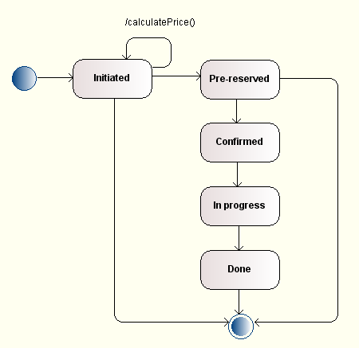

Figure 5. Behavioral state machine

A behavioral state machine indicates different states of an entity. Organizations use a state machine diagram to show how an entity reacts to different events by changing from one state to another (Parida et al., 2019). Objects respond differently to similar situations depending on what state they are in. In most cases, state machines are applied to objects with similar behavior to other entities, such as use cases and subsystems. The development of a state machine involves events, transitions, and actions.
CRUDE Analysis
The CRUDE analysis is a technique used to identify use cases in an information system. In CRUDE analysis, the analyst determines all the data elements in a system and creates a use case that involves reading or reporting, updating, and deleting unnecessary data items.
Figure 6. CRUDE Analysis
Data Entity | CRUDE | Resulting Use Case
Customer | Create | Add new customer
 | Read | Find customer
 | Update | Update customer information
 | Delete | Delete inactive customer
Order | Create | Create new order
 | Read | View order history
 | Update | Update order
 | Delete | Cancel order
Shipment | Create | Generate shipment report
 | Read | View shipment details
 | Update | Update shipment request
 | Delete | Cancel shipment request
Inventory item | Create | Add new inventory item
 | Read | View inventory item list
 | Update | Update inventory item
 | Delete | Delete inventory item

Verification and Validation
The functional business model is a comprehensive description of company operations performed daily to achieve the organization's mission. Functional models show the essential business processes that every organization undertakes in different departments. Behavioral models indicate what happens when a system reacts to a stimulus generated by the environment (Howard et al., 2017). The main assumption in behavioral models is that data arrives in the system and has to be processed. Additionally, the behavioral model assumes that events that happen are associated with data, stimulating system processing. The processing in behavioral models in ABS involves the generation of output and sequence of actions on the data. Therefore, the behavioral model in ABS is controlled by the data input with a little external event processing force. Structural models describe the structure of objects that are supported by the organization's process. Structural models assume that counterfactual predictions are based on deep unobservable parameters of decision making.

References
Bidmon, C. M., & Knab, S. F. (2018). The three roles of business models in societal transitions: New linkages between business model and transition research. Journal of Cleaner Production, 178, 903-916.
Geissdoerfer, M., Vladimirova, D., & Evans, S. (2018). Sustainable business model innovation: A review. Journal of cleaner production, 198, 401-416.
Howard, A. G., Zhu, M., Chen, B., Kalenichenko, D., Wang, W., Weyand, T., ... & Adam, H. (2017). Mobilenets: Efficient convolutional neural networks for mobile vision applications. arXiv preprint arXiv:1704.04861.
Parida, V., Sjödin, D., & Reim, W. (2019). Reviewing literature on digitalization, business model innovation, and sustainable industry: Past achievements and future promises.

